**PHYSICS P510/1**

**SENIOR FIVE PROGRESSIVE TESTS**

**Time: 1 hour and 30 minutes**

Where necessary assume;

* Acceleration due to gravity, **g = 9.81ms-2**
* *Avogadro’s number* ***NA = 6.02 x 1023 mol-1***

**Attempt all numbers**

1. **(a**)(i) define linear momentum ( 01 mark )

**(ii)** State the principle of conservation of linear momentum. (01 mark)

**(b)** A truck, **P** of mass **0.20kg** and a second truck, **Q** of mass **0.10kg** are at rest on two horizontal straight roads along which they can move with negligible friction. **P** is acted on by a force of **0.10N** which makes an angle of **300** with the road. After, **P** has travelled **0.50m**, the force is removed and, **P** collides with, **Q** and they stick together. Calculate;

**(i)**The work done by the force (03 marks)

**(ii)** The speed of, **P** before collision (03 marks)

**(iii)** The speed of the combined trucks after collision (03 marks)

**(C)** Define the following ( 03 marks)

**(i)** Coplanar forces

**(ii)** Conservative forces

**(iii)** Coefficient of friction

**(d)** Diagram bellow shows a safety valve which releases steam when the pressure rises above a pre-determined valve. The mass of the rod and the valve cover are negligible.

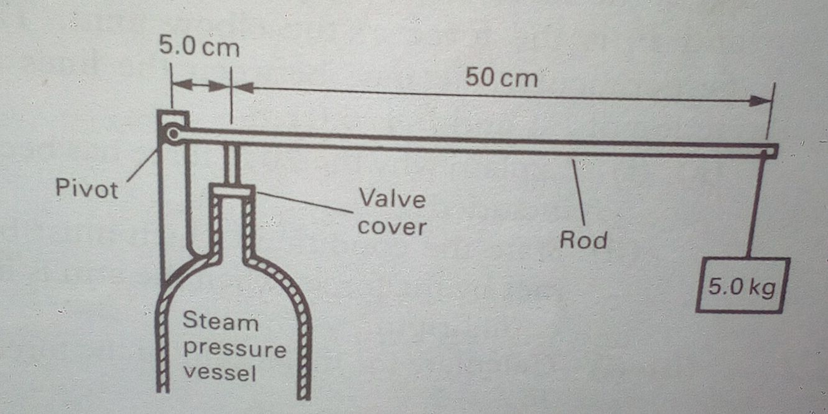

1. Draw a diagram showing the forces acting on the rod. ( 02 marks)
2. Determine the magnitude of the force at the valve which just opens the valve (04 marks)
3. **(a)** Define specific heat capacity of a substance ( 01 mark)

**(b)** **3kg** of molten lead (melting point **600K**) is allowed to cool down until it has solidified. It is found that the temperature of lead falls from **605K** to **600K** in **10 S**, remains constant at **600K** for **300S** and then falls to **595K** in further **8.4S**. Assuming that specific heat capacity of solid lead is **140Jkg-1K-1**, Calculate;

(i) The rate of loss of heat from lead (03 mark)

(ii) Specific latent heat of fusion of lead (03 marks)

1. The specific heat capacity of liquid lead (03 marks)

**(c)** **(i)** State Newton’s law of cooling ( 01 mark)

**(ii)** Describe an experiment to determine cooling correction of a poorly conducting solid. (07 marks)

**(d)** Define conduction and temperature gradient (02 marks)

**3. (a)** Define the following (02 marks)

**(i)** Radioisotopes

**(ii)** Activity of a radioactive sample

**(b) (i)** Briefly outline the steps taken to determine activity of a sample using G.M tube (03 marks)

**(ii)** derive the relationship between half-life and decay constant using the expression ,  **A = $A_{0}$ $e^{-λt}$.** (04 marks)

**(c)** A sample of ${}_{92}^{235}U$, undergoes fission according to the equation below.

${}_{92}^{235}U$**+ ${}_{0}^{1}n$ ${}_{56}^{141}{Ba}$ + ${}_{36}^{92}{kr}$ + 3 ${}_{0}^{1}n$**

1. Give two conditions for such a reaction to take place (02 marks)
2. Calculate the energy released during the reaction if **10kg** of sample decayed.

**( $Mass of {}_{92}^{235}U$ = 235.04 U, mass of ${}_{56}^{141}{Ba}$ = 140.91U, mass of ${}_{36}^{92}{kr}$ = 91.91U, mass of ${}_{0}^{1}n$ = 1.01U, 1U = 932MeV)** (07marks)

1. Give a reason why the reaction above is called a chain reaction. ( 01 mark)